**DAILY ONLINE ACTIVITIES SUMMARY**

|  |  |  |  |  |  |  |  |  |
| --- | --- | --- | --- | --- | --- | --- | --- | --- |
| **Date:** | **27-05-2020** | | | | | **Name:** | **Shiza Amreen.J** | |
| **Sem & Sec** | **4th sem B sec** | | | | | **USN:** | **4AL18CS078** | |
| **Online Test Summary** | | | | | | | | |
| **Subject** | | **Object Oriented Concepts** | | | | | | |
| **Max. Marks** | | **30** | | **Score** | | | **24** | |
| **Certification Course Summary** | | | | | | | | |
| **Course** | **Python for Machine Learning** | | | | | | | |
| **Certificate Provider** | | | **Great ,learning** | | **Duration** | | | **5 Hours** |
| **Coding Challenges** | | | | | | | | |
| **Problem Statement:** 1. In Bubble sort, each pass consists of comparison each element in the file with its successor (i.e. x[i] with x[i+1]) and interchanging two elements if they are not in the proper order. The array may be sorted in any pass. If the array is sorted, then remaining passes should be skipped off. Write a C Program to sort an array of integers in ascending order and display the sorted array and Number of passes performed for sorting.  2. [Given an array arr[] of the positive integers of size N, the task is to find the largest element on the left side of each index which is smaller than the element present at that index. Note: If no such element is found then print -1.](https://github.com/orgs/alvas-education-foundation/teams/2nd-year/discussions/82) | | | | | | | | |
| **Status: completed** | | | | | | | | |
| **Uploaded the report in Github** | | | | | **yes** | | | |
| **If yes Repository name** | | | | | **Lockdown_Coding** | | | |
| **Uploaded the report in slack** | | | | | **yes** | | | |

Online Test Details:

Today I had Object Oriented Concepts IA-2, I have attended the test and scored 24 out of 30, and have submitted it.



Certification Course Details:

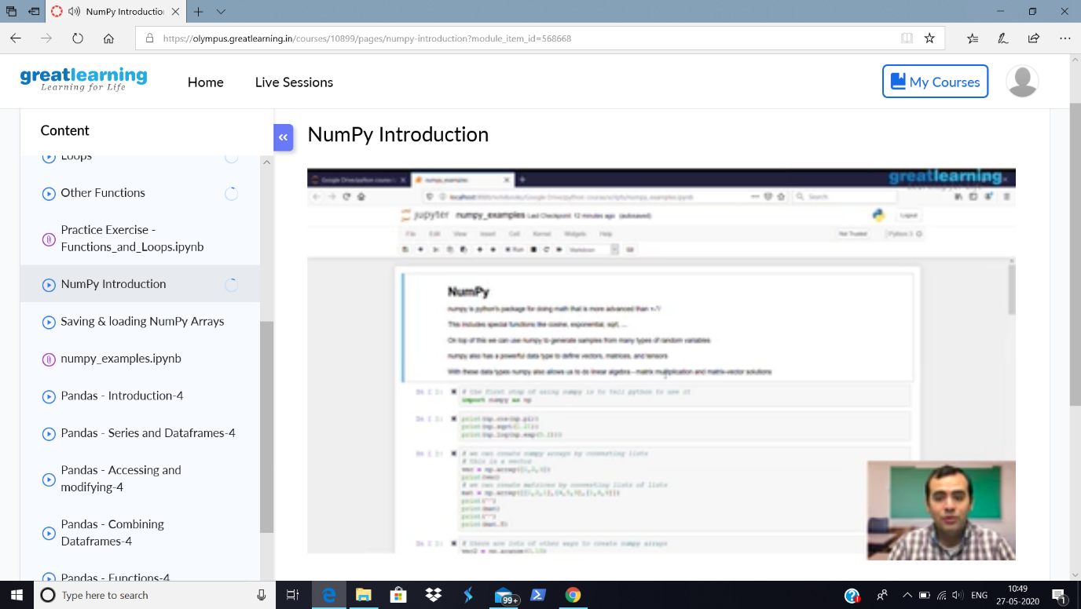

As I have taken the course, Python for Machine Learning, Today I have learnt about the numpy and its functions.

Coding Challenges Details:

|  |
| --- |
| **Problem Statement:**  1. In Bubble sort, each pass consists of comparison each element in the file with its successor (i.e. x[i] with x[i+1]) and interchanging two elements if they are not in the proper order. The array may be sorted in any pass. If the array is sorted, then remaining passes should be skipped off. Write a C Program to sort an array of integers in ascending order and display the sorted array and Number of passes performed for sorting.  2. [Given an array arr[] of the positive integers of size N, the task is to find the largest element on the left side of each index which is smaller than the element present at that index. Note: If no such element is found then print -1.](https://github.com/orgs/alvas-education-foundation/teams/2nd-year/discussions/82) |

I have written the code for above problem statements and have uploaded in my Github repository, Lockdown_Coding.

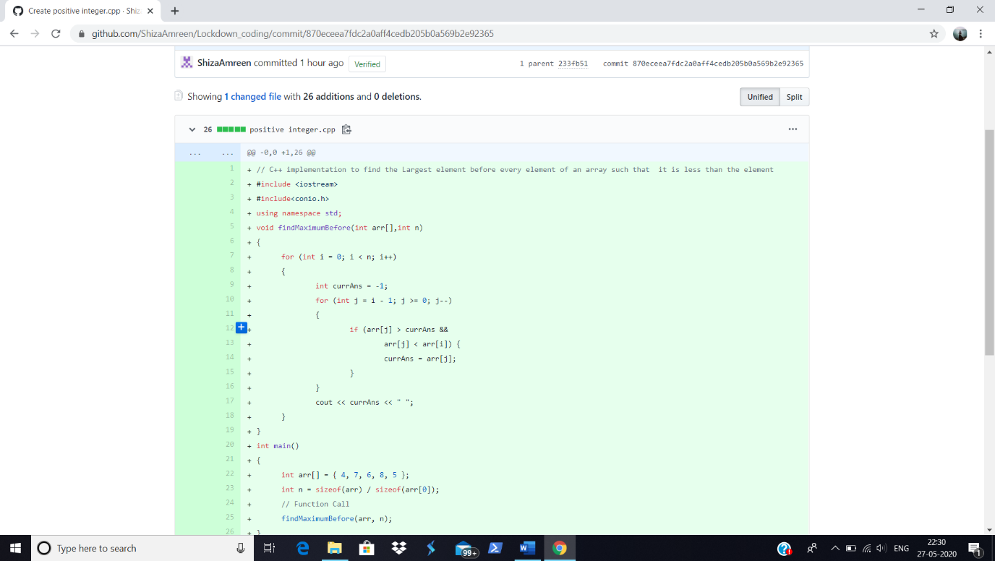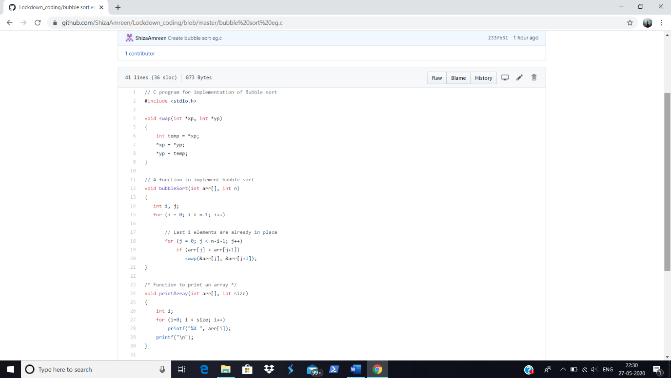

<https://github.com/ShizaAmreen/Lockdown_coding>